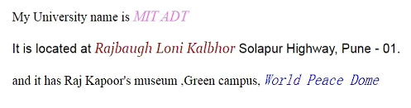
HTML code

<!DOCTYPE html>
<html lang="en">
<head>
<meta charset="UTF-8">
<meta name="viewport" content="width=device-width, initial-scale=1.0">
<title>Formatted University Info</title>
</head>
<body>
<p>
My University name is <span style="font-style: italic; color: purple;">MIT ADT</span><br>
<strong>It is located at <span style="color: brown; font-style: italic;">Rajbaugh Loni Kalbhor</span> Solapur Highway, Pune - 01.</strong><br>
and it has Raj Kapoor's museum, Green campus, <span style="font-style: italic; color: blue;">World Peace Dome</span>
</p>
</body>
</html>

